Observation Details Dialog

The details of an individual observation can be viewed by selecting an observation in the Plot pane such that the cross hair is upon it, e.g.

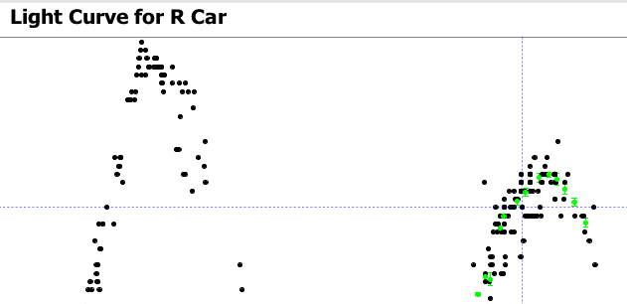

Selecting a row in the observation list is equivalent to this, e.g.

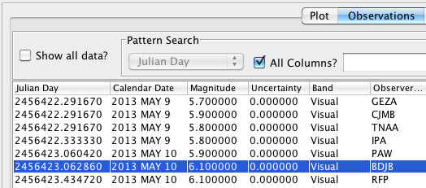

The observation details dialog is invoked from the View menu or via the corresponding toolbar button:

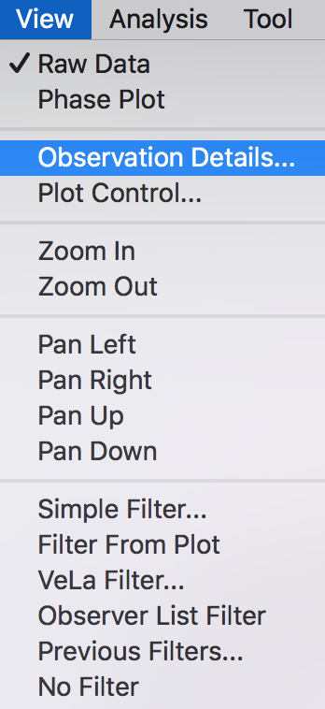

The observation in this example was a visual estimate of R Car made by the author:
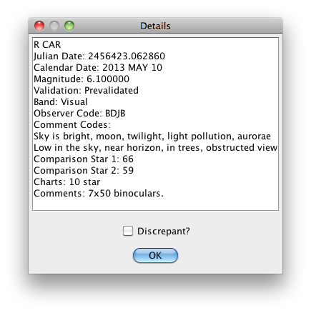
If a phase plot has been created, the phase will also be shown. If the time is a Heliocentric Julian Date rather a Julian Date, this will be indicated. Other details will differ depending upon the kind of observation (e.g. visual vs photometric), the observer, comment codes, band, and so on.

Note that the same information is available in the Observation List; however it can be useful to have multiple observation details dialogs open simultaneously, especially when observations are separated widely in time.

Selecting the Discrepant? checkbox relegates the observation to the discrepant series. This can be made visible on the plot via the Plot Control Dialog. If the dataset was loaded from the AID, another dialog will be opened, asking whether to submit a discrepant report to AAVSO HQ, e.g.
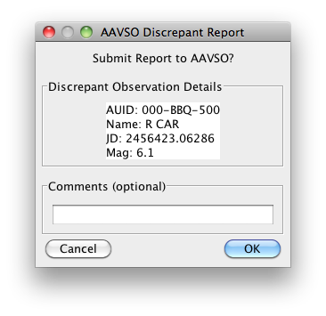
Of course, this particular observation is fine and no discrepant report was actually submitted. Before the observation report is sent, you will be asked to authenticate with your AAVSO web credentials.

This same Discrepant checkbox and reporting capability also exists in each Observation List row.

To find out more about the criteria for reporting an observation as discrepant, see the Zapper tool's online help: http://www.aavso.org/sites/default/files/software/zapper/zapperhelp.pdf

